LINUX BASIC COMMANDS

1. pwd

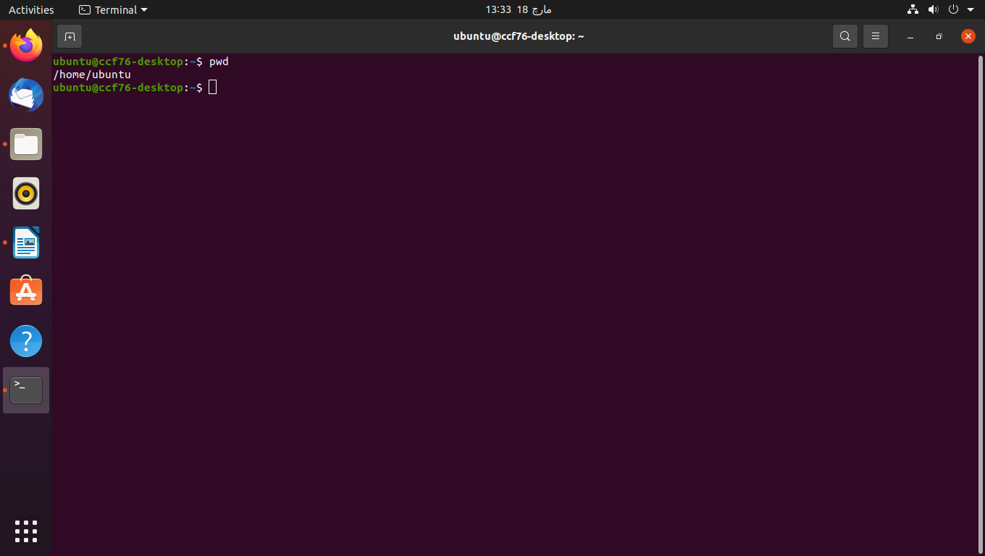

2. ls

eg: ls -a

ls -l

ls -lh

ls -ld

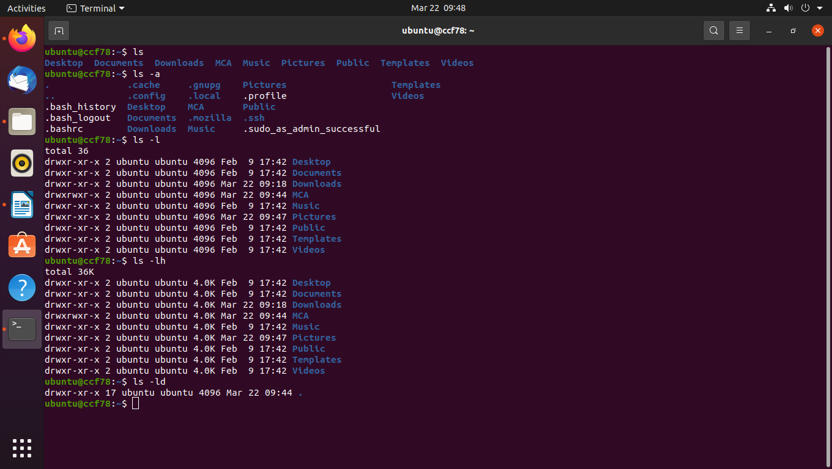

3. cd

eg: cd Downloads

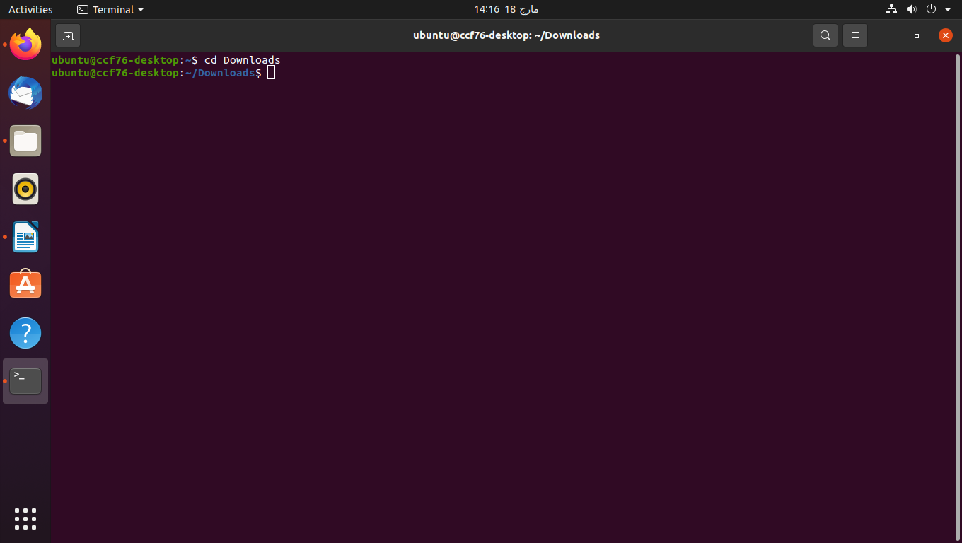

4. mkdir and rmdir

eg: mkdir MCA

rmdir MCA

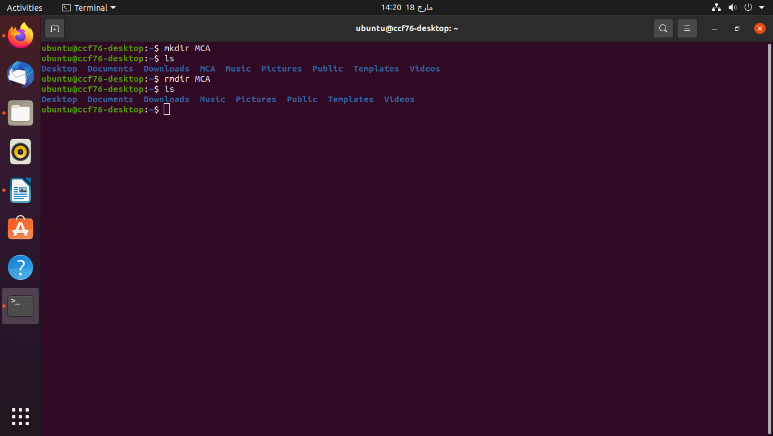

5. touch

eg: touch new.txt

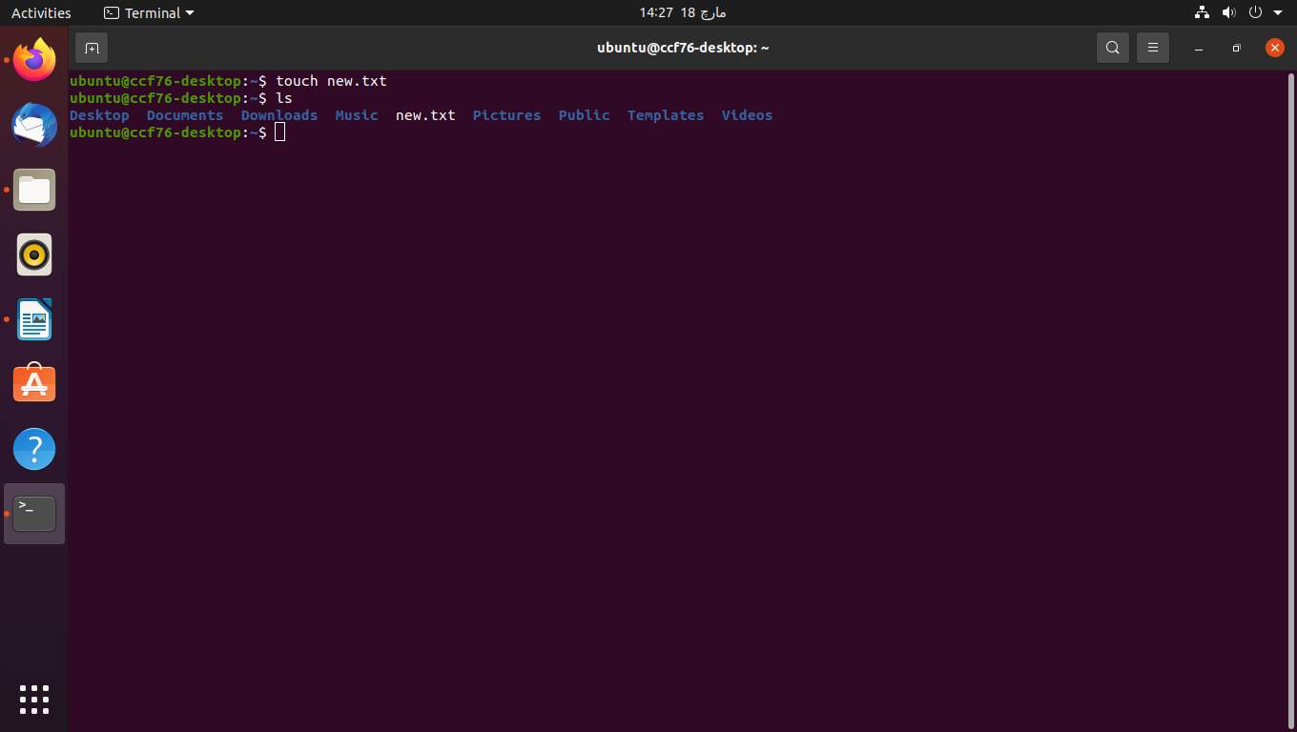

6. man

eg: man -k

man -f

man -w

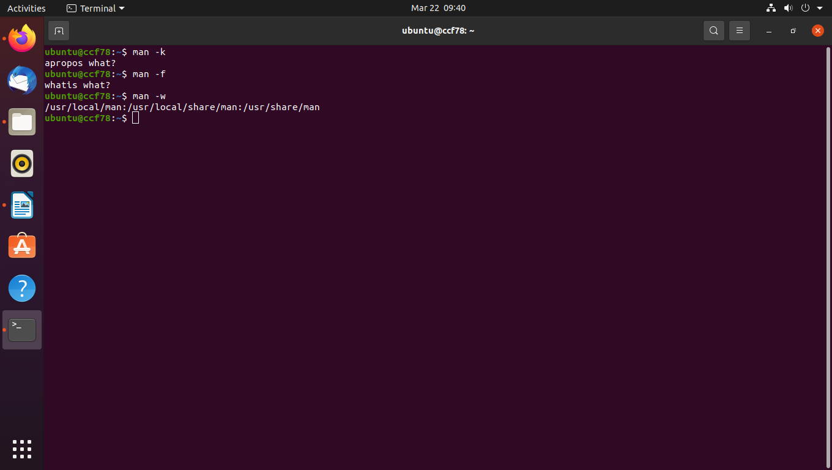

7. mv

eg: mv new.txt newer.tx

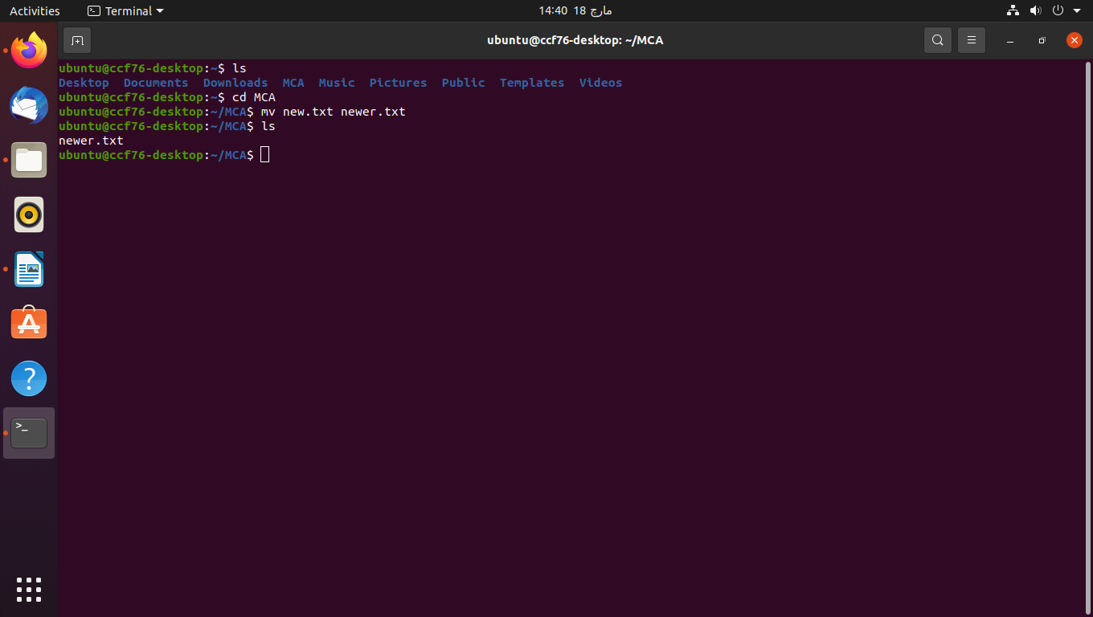

8. echo

eg: echo hello, my name is alok >> newer.txt

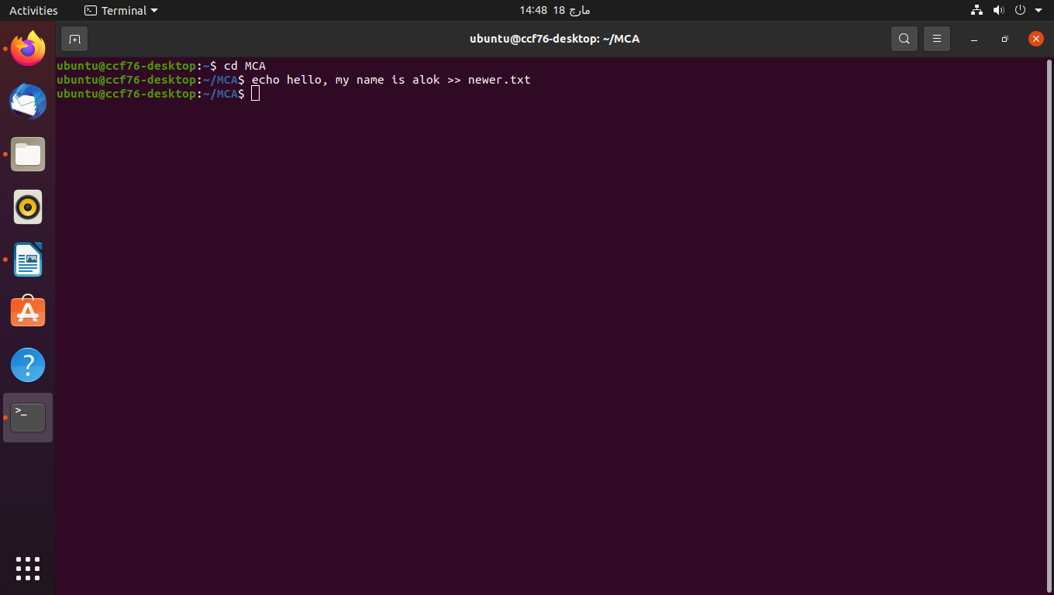

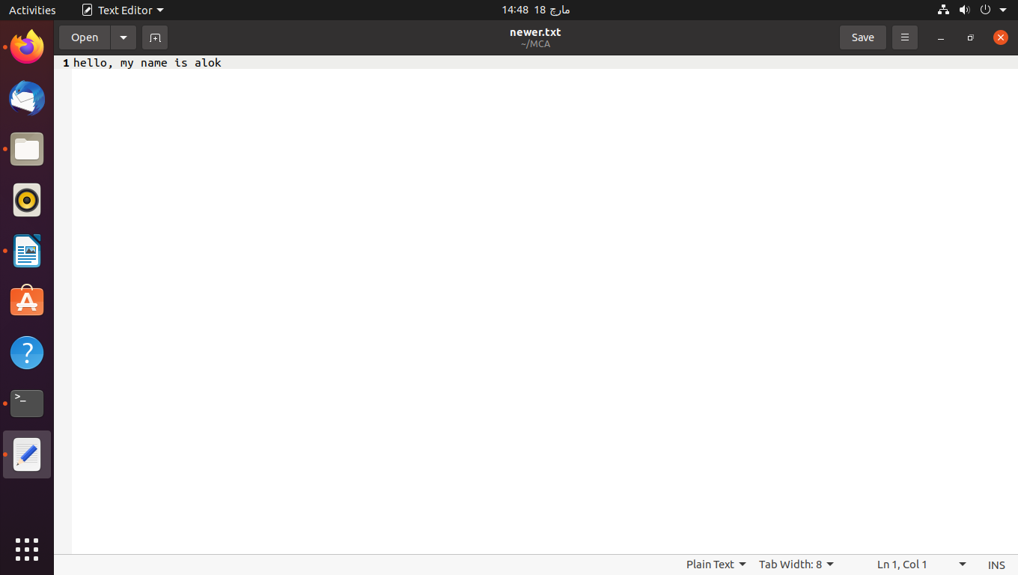

9. cat and tac

eg: cat newer.txt

tac newer.txt

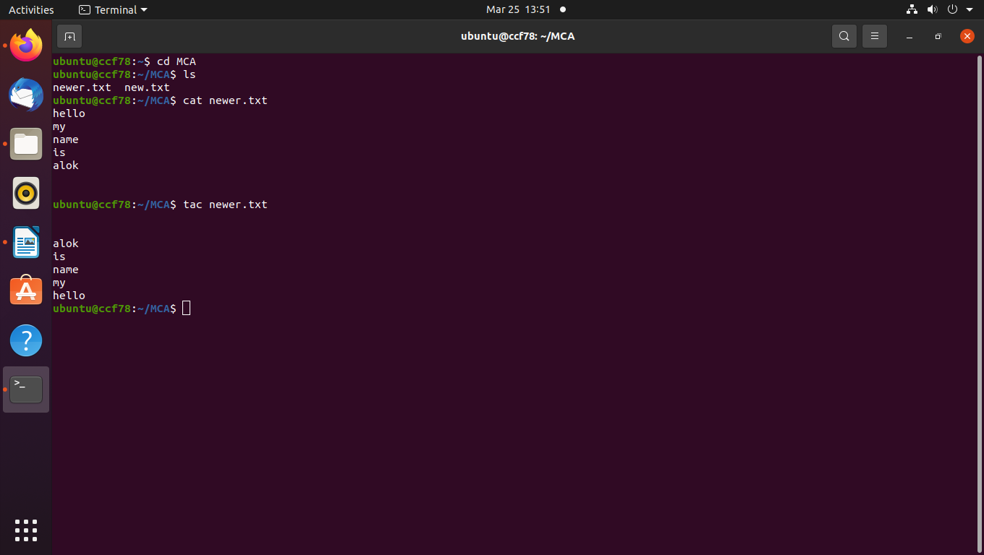

10. find

eg: find newer.txt

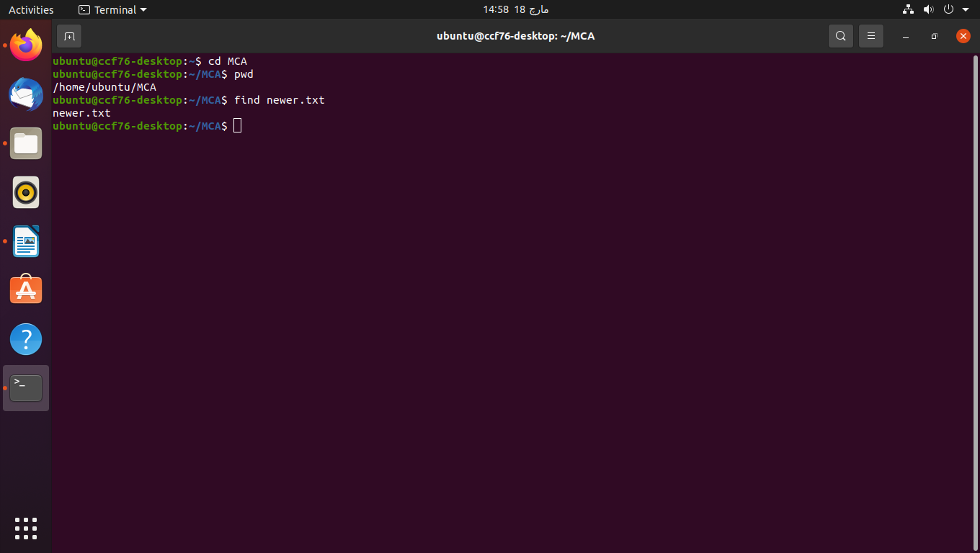

11. df and du

eg: df -m

du Downloads

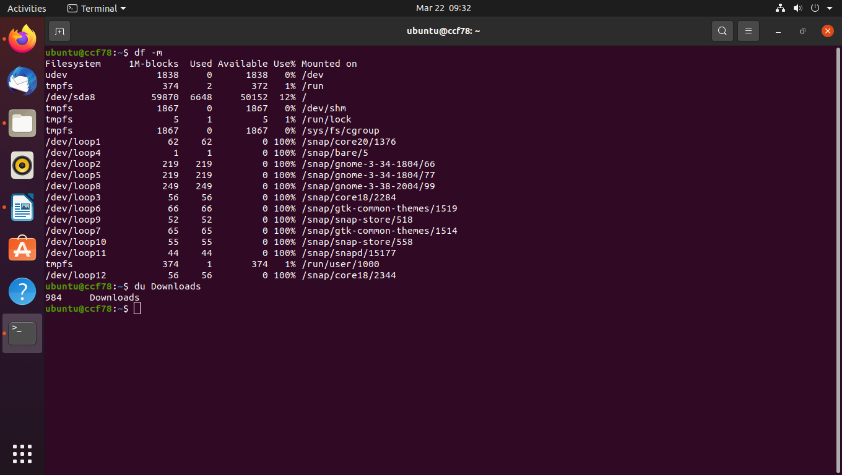

12. uname

eg: uname -a

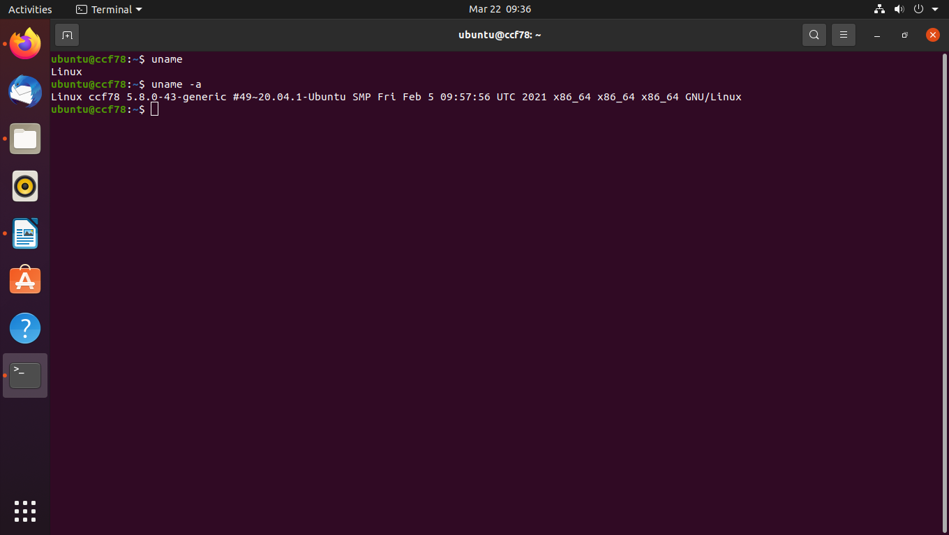

13. sudo and passwd

eg: sudo su

sudo passwd

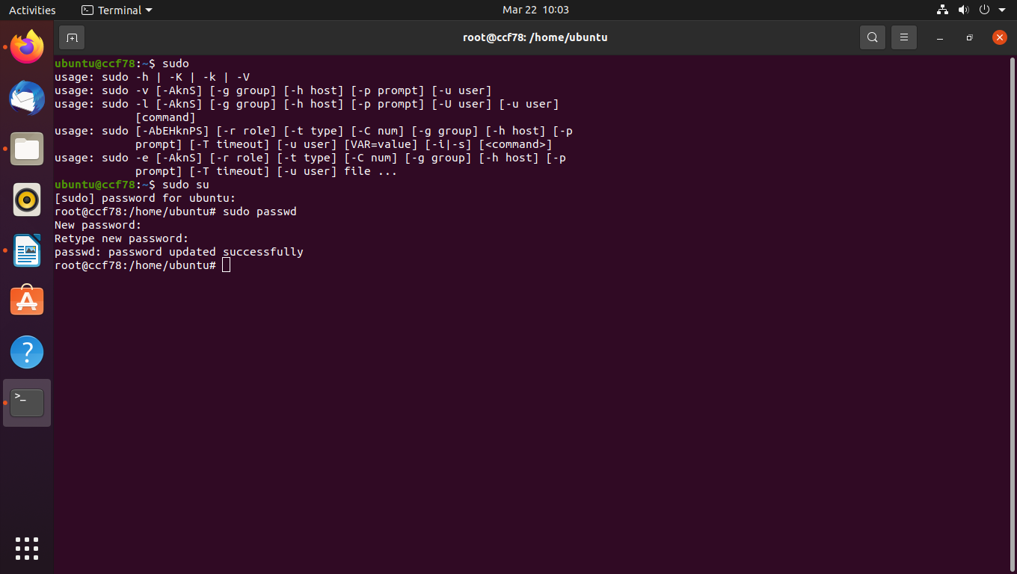

14. rm

eg: rm new.txt

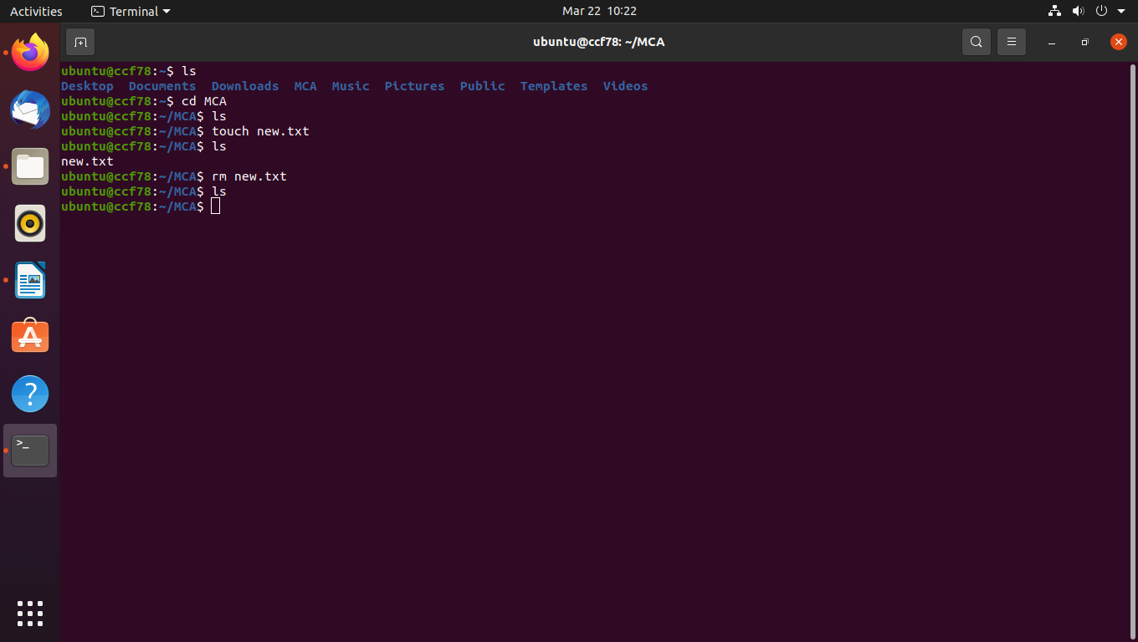

15. cp

eg: cp new.txt newer.txt

cp new.txt Documents

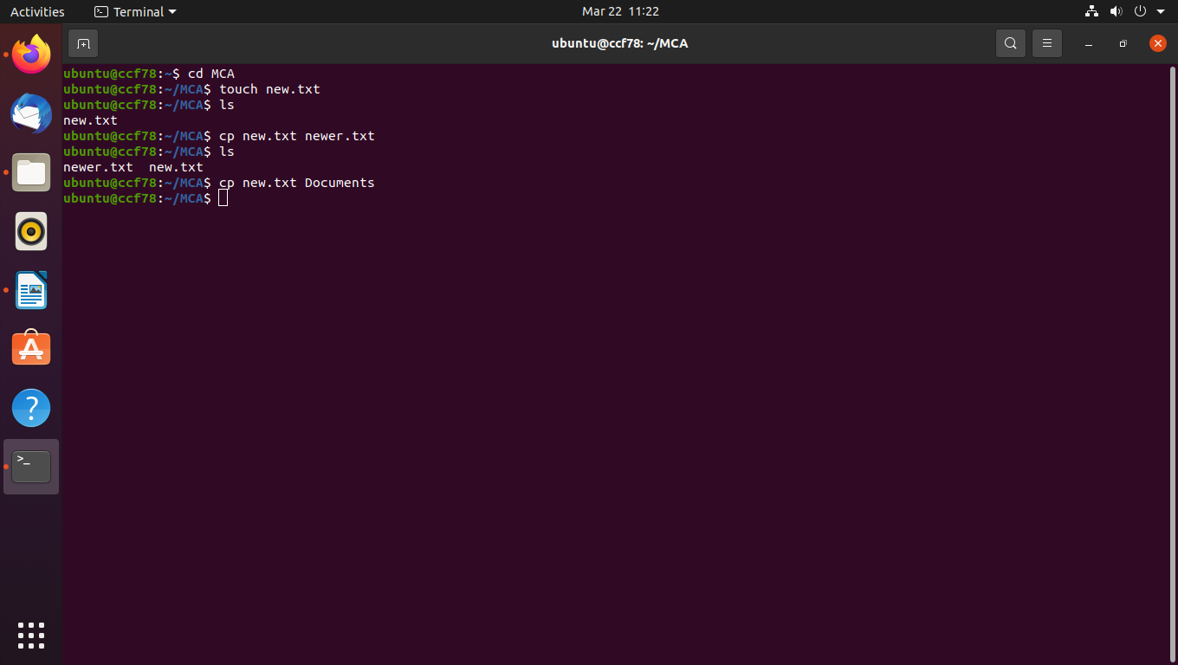

16. head and tail

eg: head new.txt

tail new.txt

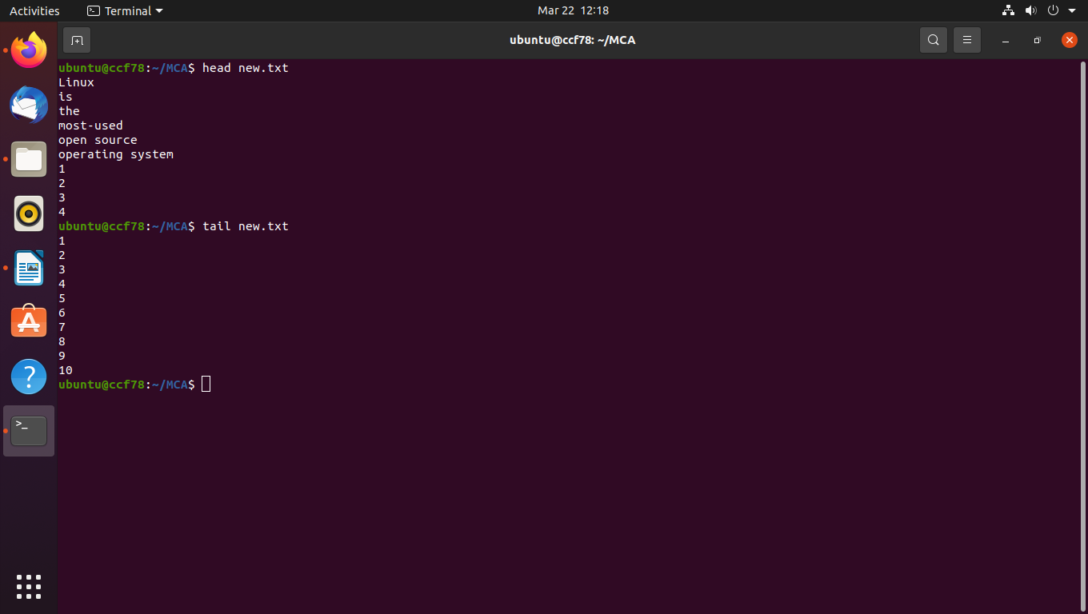

17. read

eg: echo "what is your name..?";read name;echo "hello $name"

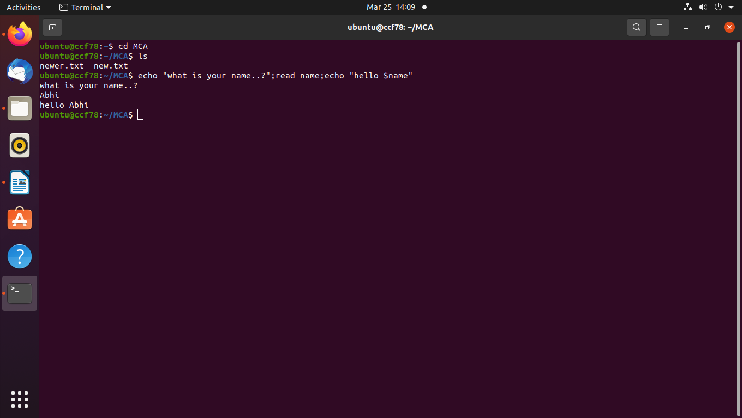

18. more

eg: more file1.txt

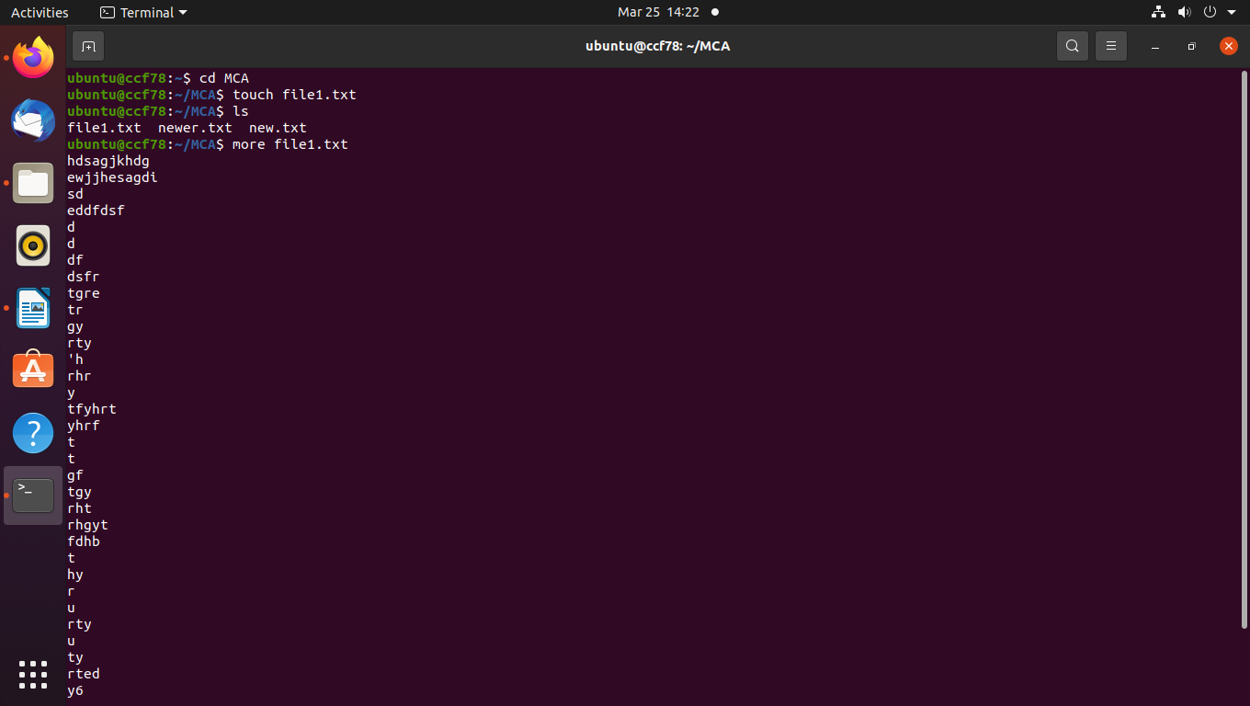

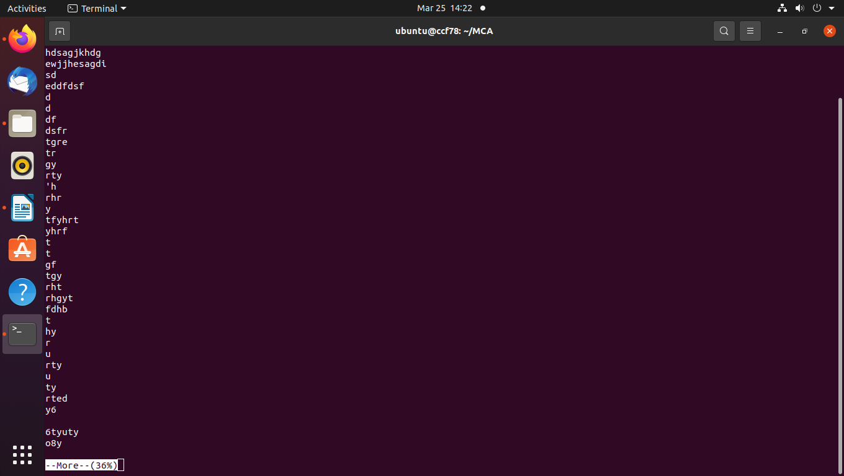

19. less

eg: less file1.txt

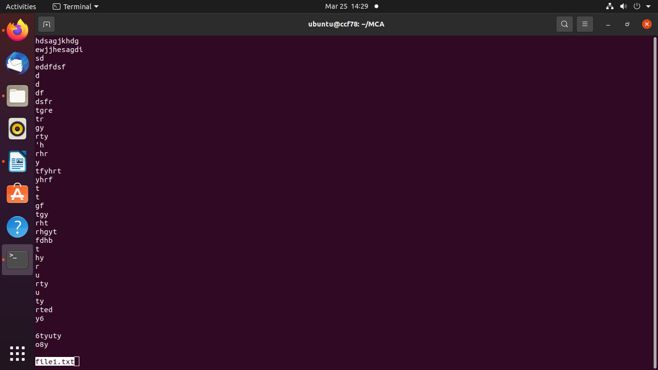

20. useradd

eg: sudo useradd James

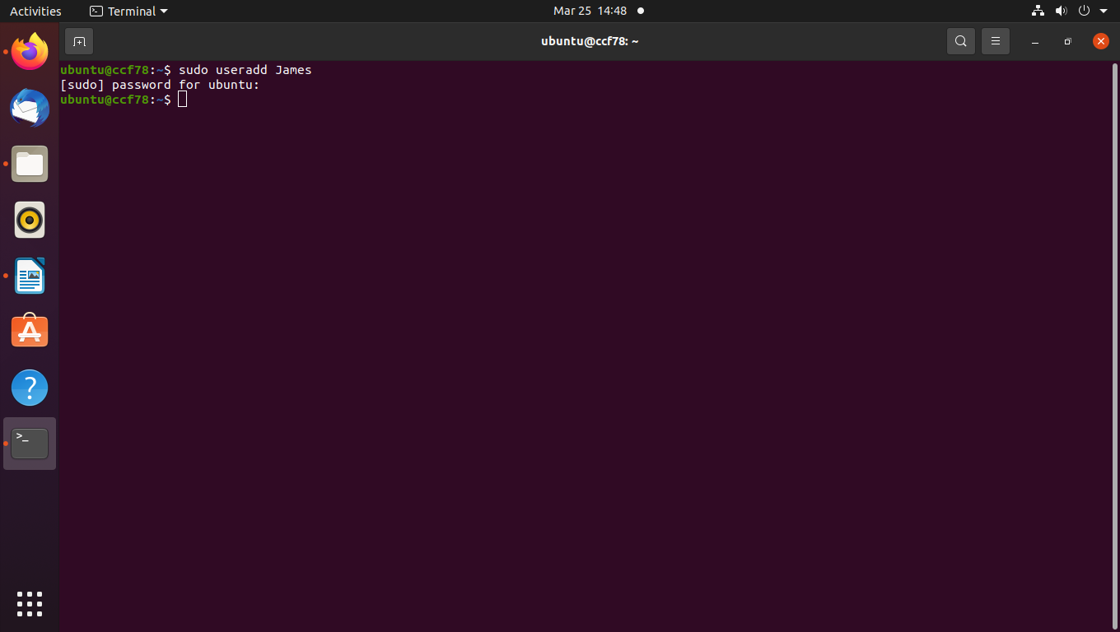

21. passwd

eg: sudo passwd James

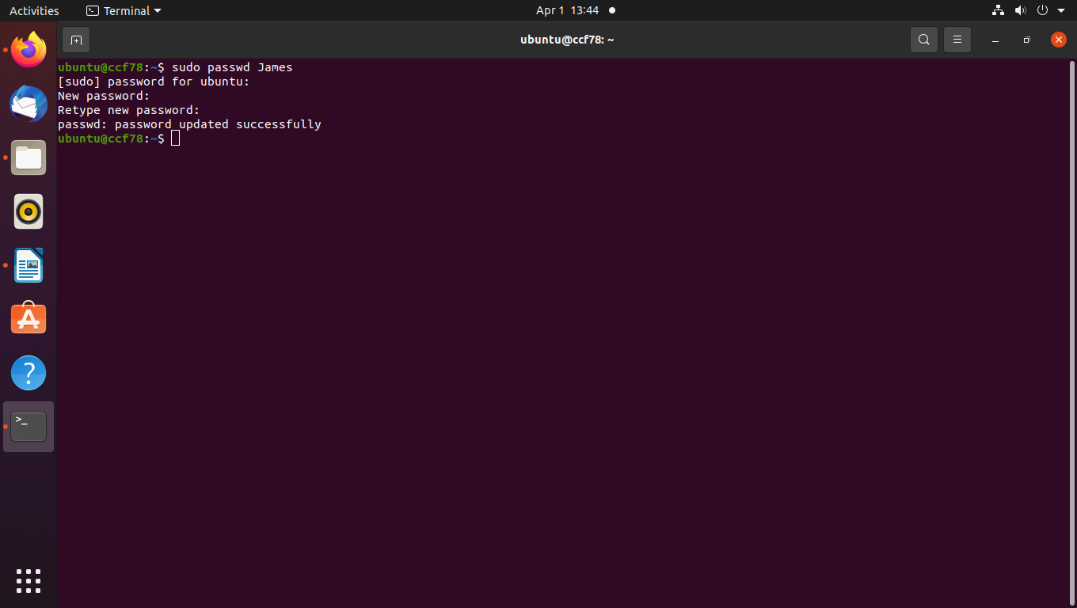

22. usermod

eg: sudo usermod James

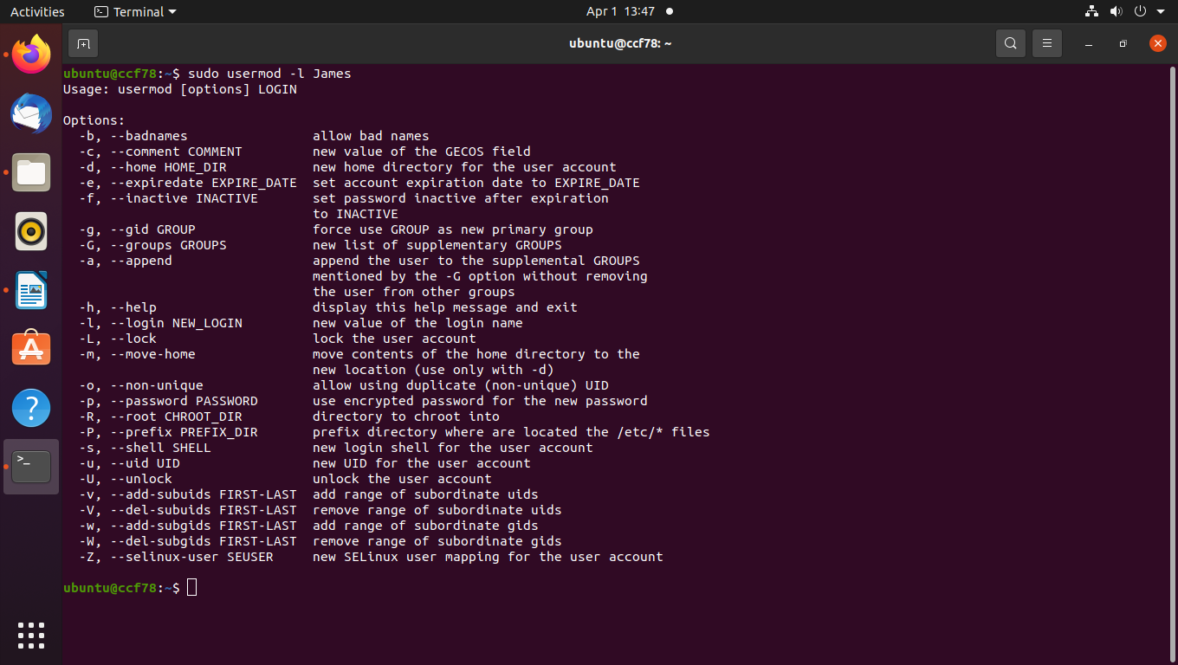

23. userdel

eg: sudo userdel Steve

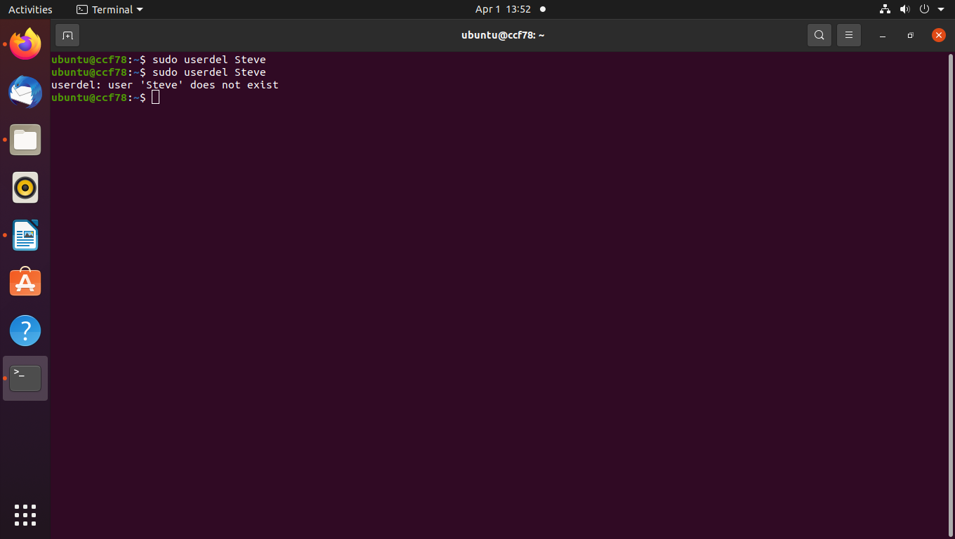

24. cut

eg: cut -b -2 newer.txt

cut -c 2,3 newer.txt

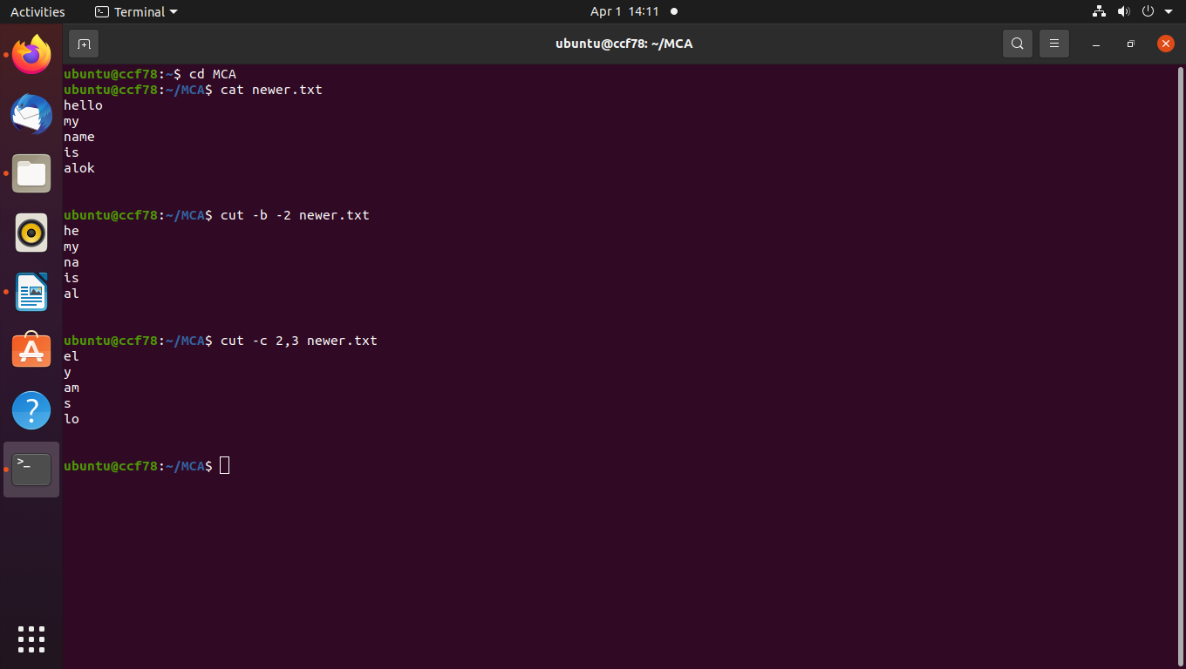

25. paste

eg: paste file1.txt newer.txt

paste -d '_' file1.txt newer.txt

paste -s file1.txt newer.txt

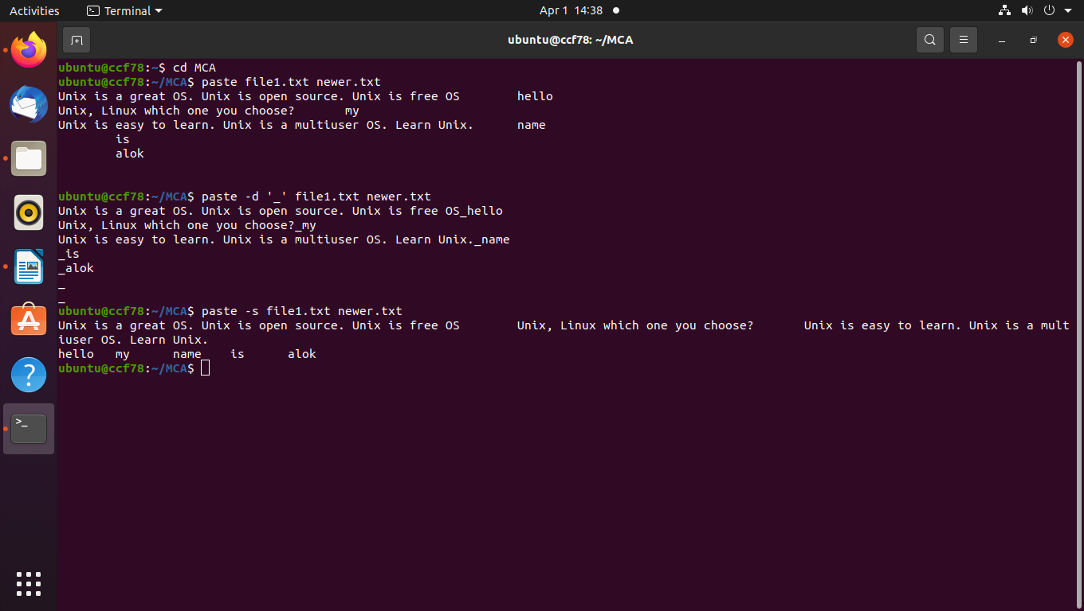

26. grep

eg: grep -i “Unix” file1.txt

grep -c “Unix” file1.txt

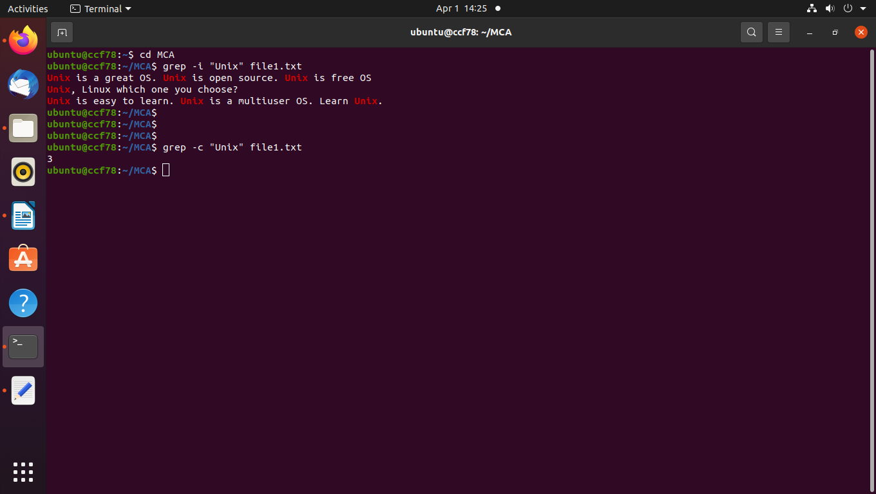

27. wc

eg: wc file1.txt

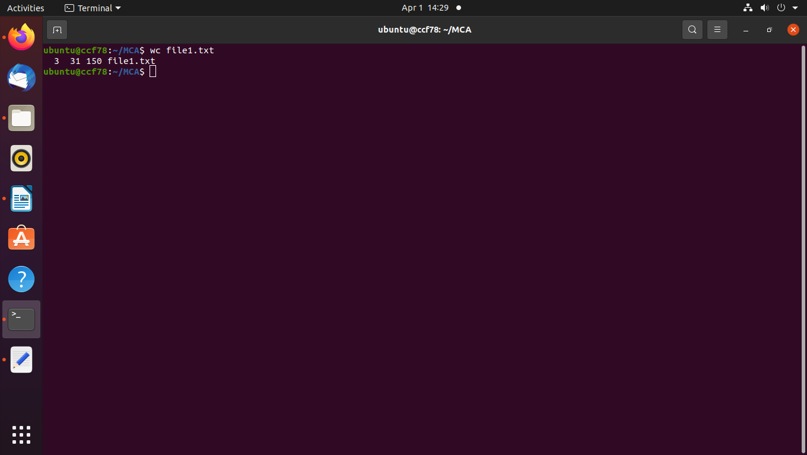

28. expr

eg: expr 3 + 5

expr 5 \* 6

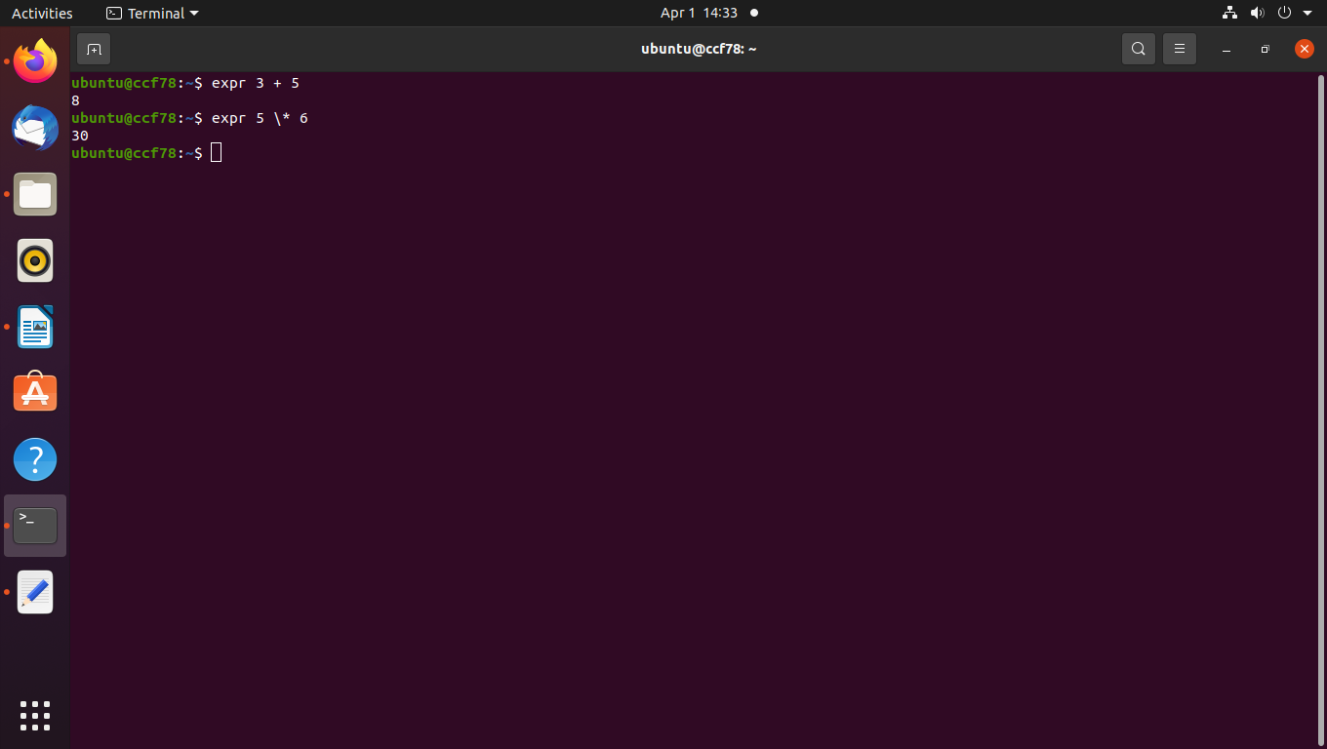

29. top

eg: top -h

top -v

top -b

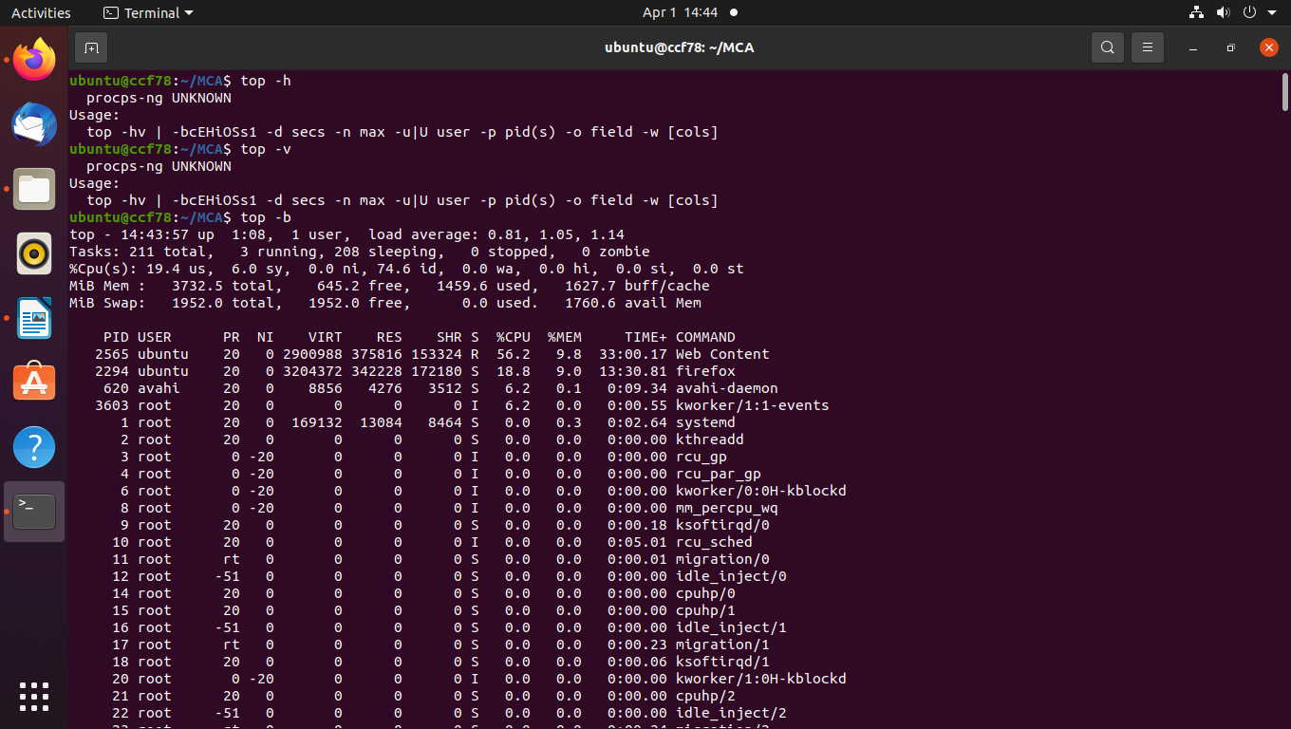

30. ps

eg: ps -u

ps -ax

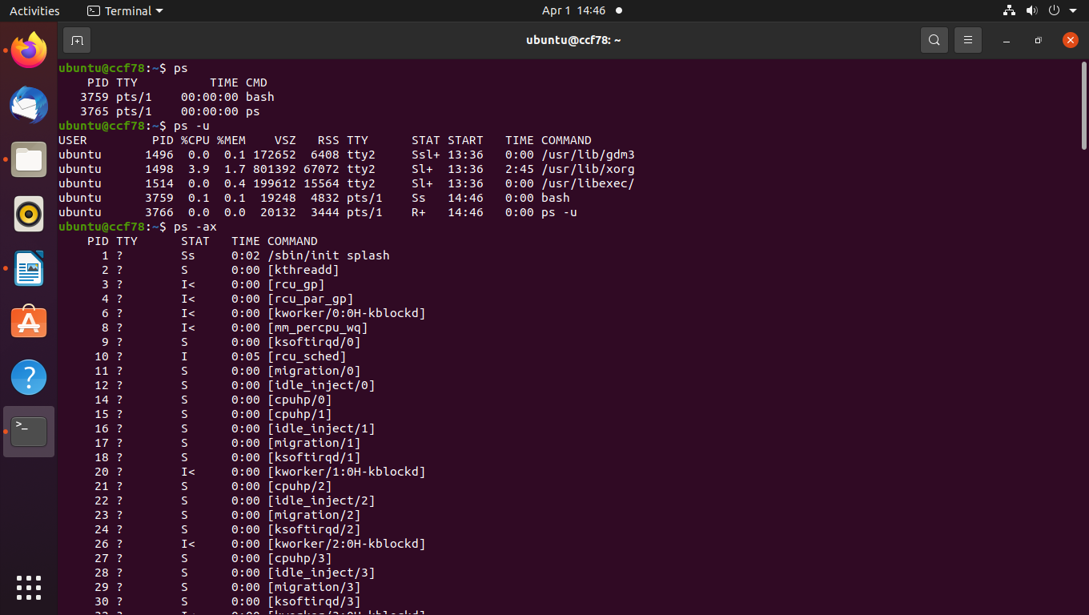

31. chmod

eg: chmod -c +w newer.txt

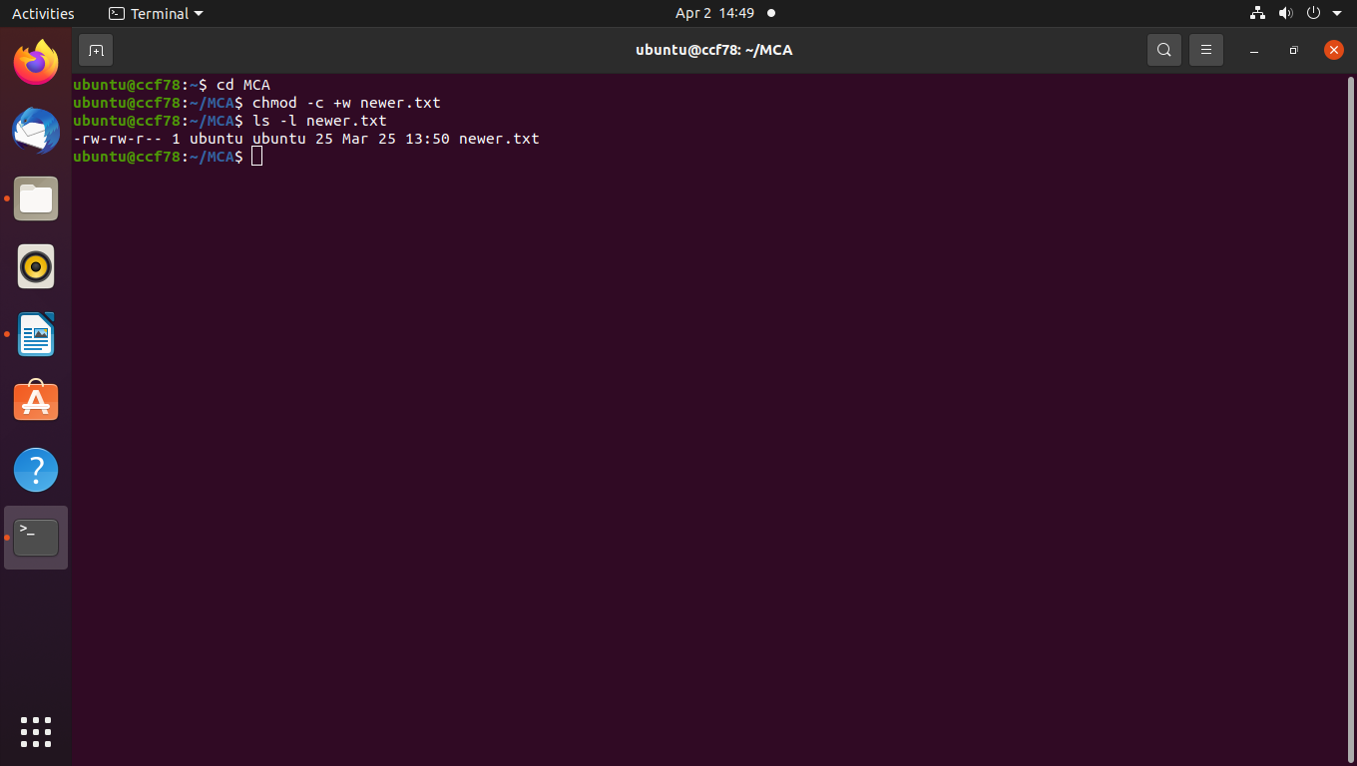

32. chown

eg: chown root newer.txt

chown -c root newer.txt

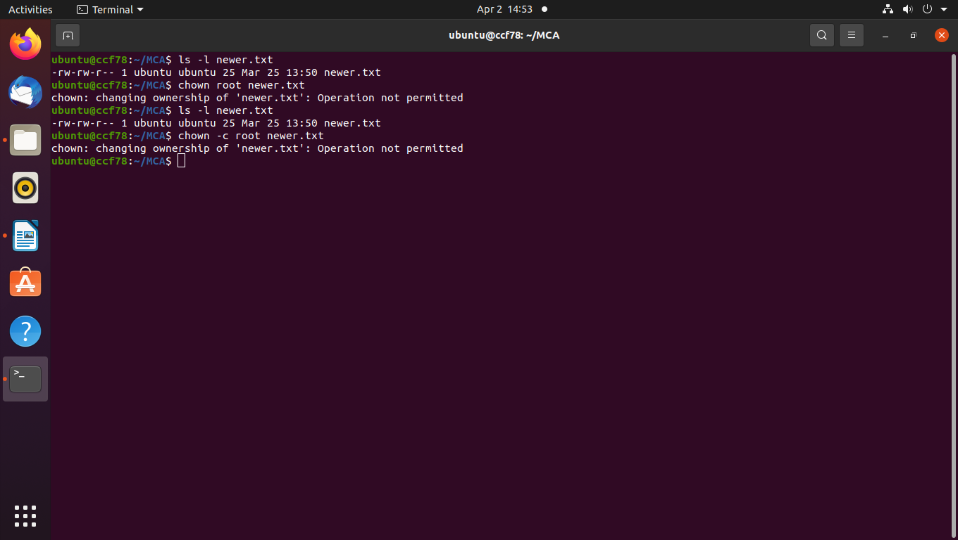

33. tar

eg: tar -cvf file.tar *.txt

tar -xvf file.tar *.txt

tar -cvf file.tar.gz *.txt

